**Qazi Nisar Ahmad**

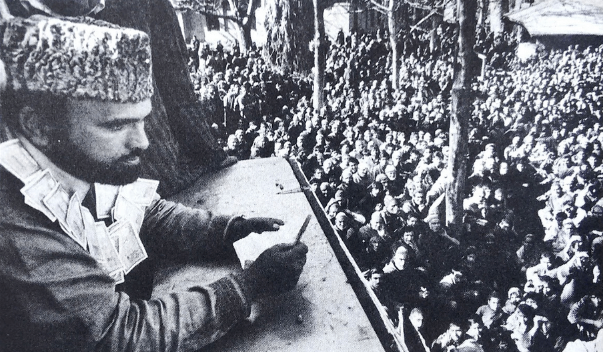

**About:** Qazi Nisar Ahmad was born in 1952, the son of Qazi Ghulam Mohammed, who had earned the title of Fakhr Ul Waizeen (The Pride of Preachers) due to his social services in South Kashmir. The then Mirwaiz, Qazi Ghulam Mohammed was a son of Qazi Qamar-u-Din, who was seen as a wizard. His name is recorded as leading a protest against the autocratic [Dogra](https://en.wikipedia.org/wiki/Dogra_dynasty" \o "Dogra dynasty) Empire on 22 September 1933, when more than half a dozen demonstrators were shot dead by the regime's troops.]

Nisar's early education was in Nusrat ul Islam in [Islamabad](https://en.wikipedia.org/wiki/Islamabad). In 1968 he topped the class 10th board exams in the state of Jammu Kashmir. He earned the highest score in Kashmir province in 1970 class 12th board Exams. He later studied at [Aligarh Muslim University](https://en.wikipedia.org/wiki/Aligarh_Muslim_University) (AMU) where his political activities came under scrutiny. He completed his M.A and M.Phil at AMU in Islamic Studies and also studied Law. He was awarded a Gold Medal for his efforts, receiving his Ph.D in 1985. He was the first Kashmiri to study at [Al-Azhar University](https://en.wikipedia.org/wiki/Al-Azhar_University) in Cairo, Egypt.

**Murdered on:** 19 June 1994

**Attack details:** On 19 June 1994, Nisar was assassinated by gunmen at Dialgam.

**Reason to him target:** He used to go to spread Islam in both India and Pakistan. Used to do evil of India in Pakistan. This is why someone killed them.

**Occupation** Nisar returned to Kashmir in 1984 and worked at the Department of Arabic at Kashmir University. He quit the job and chose to work for his people. He served initially as a preacher at Magarmal Bagh in Srinagar, and after the death of his father, went to Islamabad to serve as the chief preacher there.

**Belief:** On 19 June 1994, Nisar was assassinated by gunmen at Dialgam His assassination resulted in a pro-New Delhi armed insurgency. Yasin Malik recalls "Dr. Qazi Nisar’s struggle and sacrifices cannot be ignored by anyone and today we all express our gratitude and love for this noble soul. Today when we remember him, we all should follow his footsteps and come forward to save our national identity and resistance movement”

**URL :** <https://en.wikipedia.org/wiki/Qazi_Nisar>

